Software Requirements Specification
For
Task Manager
Version 1.0

Prepared by
Department: Development
Debayan Samaddar | A1170 | Debayan@ulc.com

Contents
1 Introduction 1
1.1 Document Purpose 1
1.2 Product Scope 1
1.3 Intended Audience and Document Overview 1
1.4 Definitions, Acronyms and Abbreviations 1
1.5 Document Conventions 1
1.6 References and Acknowledgments 2
2 Overall Description 3
2.1 Product Perspective 3
2.2 Product Functionality 4
2.3 Users and Characteristics 4
2.4 Operating Environment 4
2.5 Design and Implementation Constraints 5
2.6 User Documentation 5
3 Specific Requirements 6
3.1 External Interface Requirements 6
3.1.1 User Interfaces 6
3.1.2 Hardware Interfaces 9
3.1.3 Software Interfaces 9
3.1.4 Communications Interfaces 9
3.2 Functional Requirements 9
3.2.1 User Settings 9
3.2.2 Facility Settings 10
3.2.3 Priority Settings 10
3.2.4 Branch Settings 10
3.2.5 Chase Definition 10
3.2.6 Chase Control Structure 10
3.2.7 Generate Chase 10
3.2.8 User wise chase 10
3.2.9 Query generation Tool 10
3.3 Behaviour Requirements 10
3.3.1 Use Case View 10
4 Other Non-functional Requirements 11
4.1 Performance Requirements 11
4.2 Safety and Security Requirements 11
4.3 Software Quality Attributes 11
5 Other Requirements 12

List Of Figures

Figure 1: Functional Requirement Flow 3
Figure 2 : Requirement Dependency Tree 4
Figure 3 : Chaser Login Panel. 6
Figure 4 : Chase Definition 6
Figure 5 : Chase Control Structure 7
Figure 6 : Generate Chase 7
Figure 7 : Details Chase View 8
Figure 8 : Mail Notification 9

Revisions
Version | Primary Author(s) | Description of Version | Date Completed
1.0 | Debayan Samaddar | First version of the Chaser Software Requirement Specification document | 22-APR-2014

Introduction

Document Purpose
Task Manager is a sub system of Chaser web application which provides any sort of task assignment e.g. E2E, C2E, E2RM, RM2E chases with the functionality of unlimited assignment. The requirements will be presented using textual descriptions to explain concepts, different types of diagrams to illustrate complicated interactions, and tables to relate relevant information.

Product Scope
Dynamic Control Structure: To Facilitate dynamic type task assignment structure.
Administration: Improved security & Management capability.
Efficiency: Safe & efficient operations of all components.
Queuing: Serve assignments on first come first serve basis.
Reporting: Employee wise chase performance, task wise chase performance, graphical chart for better representation.

Intended Audience and Document Overview
The intended audience of this document is all of the stakeholders for a project involving the development of Task Manager Software. This includes, but is not limited to, software developers, project managers, quality assurance personnel, regular employees, sales personnel, and customers.

Definitions, Acronyms and Abbreviations
Definitions:

Acronyms:
E2E: Employee to Employee
C2E: Client to Employee
E2RM: Employee to Relationship Manager (Sales Personnel)
RM2E: Relationship Manager (Sales Personnel) to Employee
ECC: Electronic Client Chase
MSC: Manage Engine Support Service
UC: Use Case
SRS: Software Requirements Specification

Document Conventions
Margin 1”
General Text Arial size 11, 12 single spaced
Comments italics

References and Acknowledgments
[1] ECC: http://192.168.1.232/ecc/
[2] Manage Engine Support Center: http://192.168.1.246:8080/
[3] Object Oriented Modeling and Design with UML-Michael Blaha, James Rambaugh.
[4] Software Engineering, Seventh Edition, Ian Sommervill.

Overall Description

Product Perspective

“Task Manager” is a subsystem of Chase software. Every Task must have a control structure which will inherit structure from base control structure. Manage Chase controller will combine Chase Definition, Chase control structure, Generate Chase, User Management & reporting tool.
Generate chase combines (Initiation/Forward/Termination/Hold Chase options)

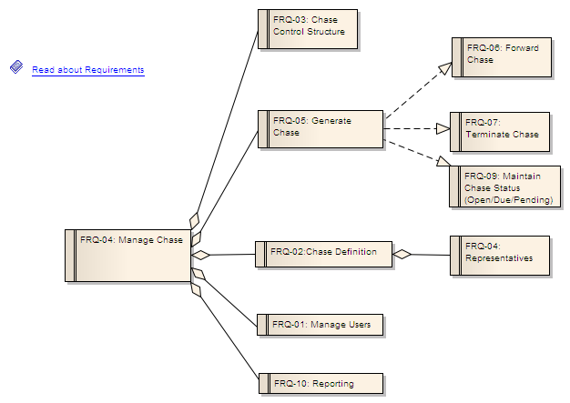
Figure 1: Functional Requirement Flow

Requirement management is depicted in below dependency tree.

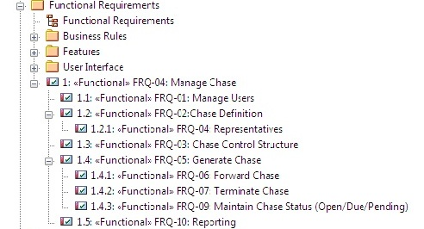

Figure 2 : Requirement Dependency Tree

Product Functionality
- User Settings
- Facility Settings
- Priority Settings
- Branch Settings
- Chase Definition
- Chase Control Structure.
- Generate Chase
- User wise chase.
- Query generation Tool

Users and Characteristics
System Admin: Users will be responsible to facilitate all types of settings & report generation query.
Superior users: can assign/forward/terminate chase & can view reports.
Operational users: can assign/forward/terminate chase.

Operating Environment
This product is web-based and will be hosted by a web server. This product can be viewed by any web browser, and has been tested for compliance with Mozilla, Internet Explorer, Netscape Navigator, and Opera.

Design and Implementation Constraints
There are no constraints at this point in time.

User Documentation
- SRS : Textual Documentation
- Technical Documentation: Use Case, Class Diagram, Collaboration Diagram, Activity Diagram, Sequence Diagram.
- User Manual.

Specific Requirements

External Interface Requirements

User Interfaces
Login Screen: Internal users will be authorized by active directory credentials.

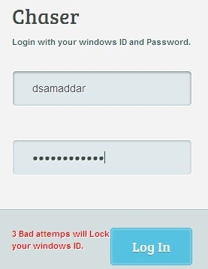

Figure 3 : Chaser Login Panel.

Chase Definition:

Defines Chase Category, Priority, representatives & notified parties.

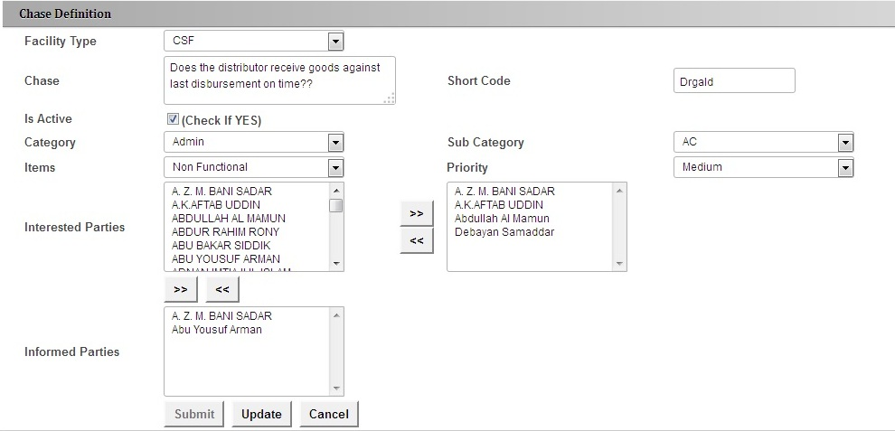
Figure 4 : Chase Definition
Chase Control Structure:

Defines how many types of control e.g. group controls (Checkbox list, Radio button List etc)
Individual controls (Label, Textbox etc)

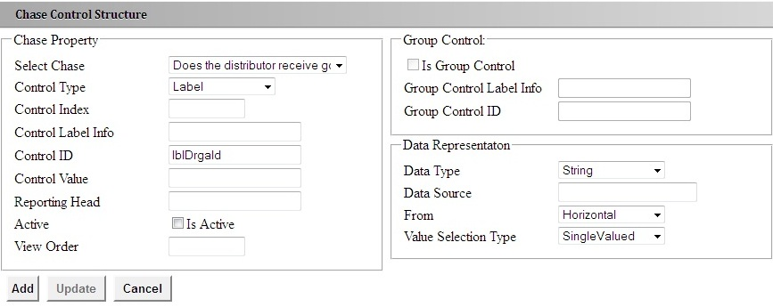
Figure 5 : Chase Control Structure

Generate Chase:

Every chase has its own dynamic control structure, which will populate while initiating chases.
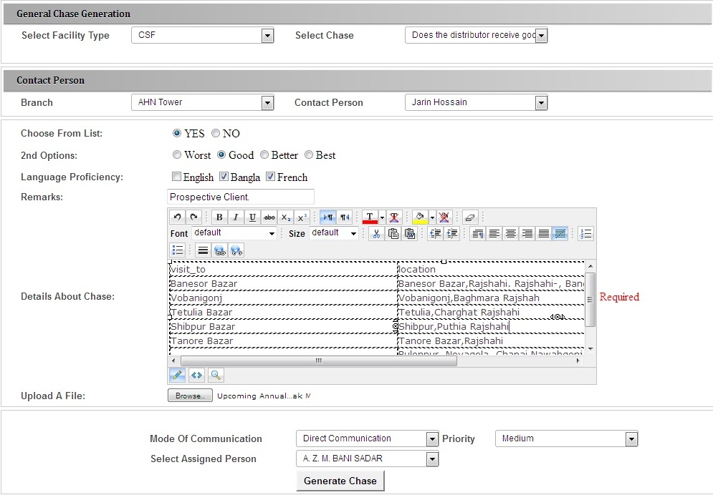

Figure 6 : Generate Chase

Chase View:

Contains Chase initiation values, chase feedback history with forward & terminate chase functionality.

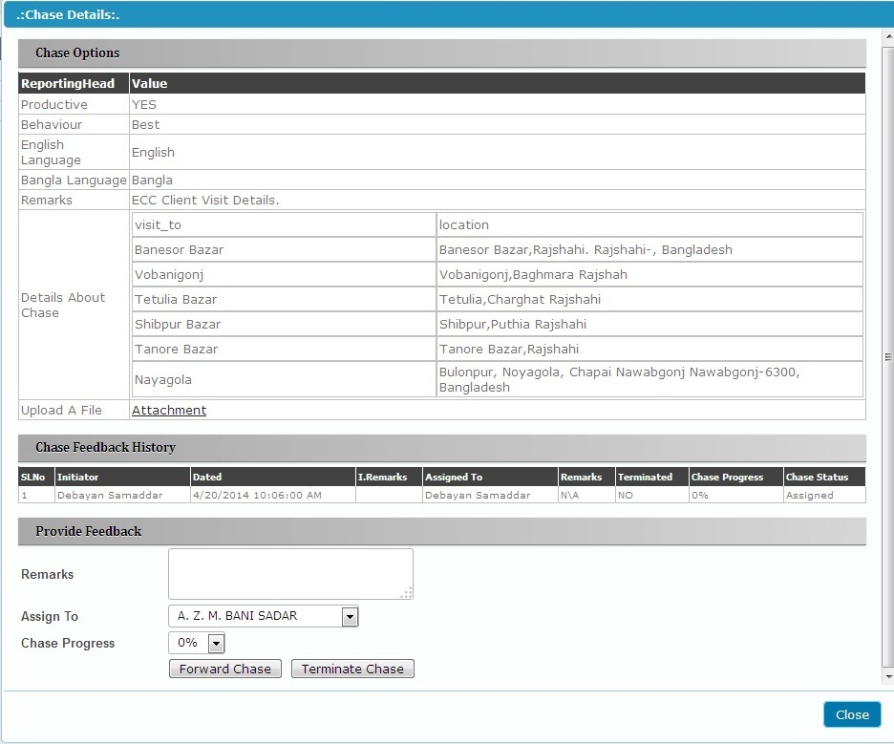
Figure 7 : Details Chase View

Mail Notification:

Auto mail notification will be circulated for any type of chase assignment, forward or termination.

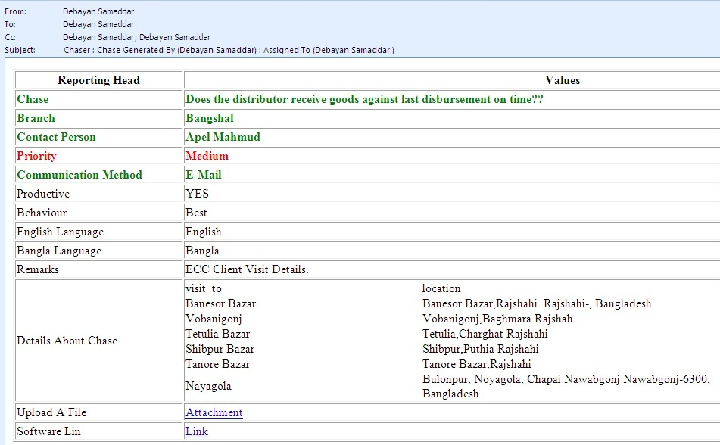
Figure 8 : Mail Notification

Hardware Interfaces
Though not necessarily interfacing with the hardware, the system must make use with an intranet connection.

Software Interfaces
The system shall make use of the operating system calls to the file management system to store
And retrieve data (uploaded files)

Communications Interfaces
Communication standard HTTP will be used.

Functional Requirements

User Settings
Manage (Insert/Update/Delete) users including Branch wise users, Credentials, activate users etc.

Facility Settings
Contains definition of different types of facility type or group of chase domain.

Priority Settings
Defines priority with timing information. Based on this information chase status will change its behaviour (Open/Hold/Due/Pending).

Branch Settings
Manage (Insert/Update/Delete) Branches. Will be useful while generating branch wise report

Chase Definition
Defines chase behaviour and its intended representatives with priority settings.

Chase Control Structure
specification of chase is defined with this option. How controls are organized with horizontal and vertical order, default values, data type definition, reporting head for further reporting.

Generate Chase
Authorized users can initiate chase predefined in chase definition.

User wise chase
View option for assigned chases & to perform Forward & Terminate chase.

Query generation Tool
generate “select” query & save option to execute the query further.

Behaviour Requirements

Use Case View
State Diagrams & use-cases will be added on next revision.

Other Non-functional Requirements

Performance Requirements
- Database Normalization 1NF, 2NF, 3NF, BCNF should be satisfied.
- Any Chase Initiation/Forward/Termination should not take more than 3 seconds to execute.
- Three tire architecture should maintain while programming for data encapsulation.
- Object oriented concept should be use to make reusable component & optimization.
- Light weight architecture.

Safety and Security Requirements
- Authentication to this software must be verified with Active Directory.
- Access to the database should be restricted to people that are required to view information about Chaser. Passwords and ID’s should be regulated to be at least a certain length and must contain non-alphanumeric characters in the password.
- User wise menu view option.

Software Quality Attributes
Listed below are some of the more important Software Quality Attributes, which have been
Identified as essential to this project.

4.3.1 Reliability
The system shall never crash, or hang, other than as the result of an operating system error. The system shall provide graceful degradation in the face of network delays.
4.3.2 Maintainability
All code shall be fully documented. Each function shall be commented with pre-and
post-conditions. All program files shall include comments concerning authorship and date of last change. Finally, the code shall be modular to permit future modifications.
4.3.3 Usability
No specific training should be necessary on the part of the Operators. The user interface shall be easy to understand and the operator should be able to start working with the software immediately.
4.3.4 Portability
The software shall be designed to run on a Microsoft Windows platform. It shall be portable in a sense that will allow it to be used on any Windows version, up to and including Windows XP.

Other Requirements
<Any other requirements not covered elsewhere in the SRS. This might include database requirements, internationalization requirements, legal requirements, reuse objectives for the project, and so on. Add any new sections that are pertinent to the project.>

Appendix A – Data Dictionary

<Data dictionary is used to track all the different variables, states and functional requirements that you described in your document. Make sure to include the complete list of all constants, state variables (and their possible states), inputs and outputs in a table. In the table, include the description of these items as well as all related operations and requirements.>

Appendix B - Group Log
Minutes from group meetings:

SL.No | Dated | Attendee | About
1. | 07-APR-2014 | SEQ,MRM,MSR,KCB,DS | Overview discussion of “Chaser” Software.
2. | 08-APR-2014 | DS,UMM | Chase flow structure & usual operational procedure.

